A Survey of Wormhole Routing Techniques in Direct Networks
Lionel M. Ni and Philip K. McKinley
Computer Volume 26 2, pp. 62-76, Feb. 1993
Abstract
Efficient routing of messages is critical to the performance of direct network systems. The popular wormhole routing technique faces several challenges – particularly flow control and deadlock avoidance.
- Introduction
Using wormhole routing, the network latency is almost independent of the path length when there is no contention and the packet length is relatively large.
- Routing
Source routing
Distributed routing
Minimal routing and nonminimal routing
- Switching techniques
Store-and-forward switching(packet switching)
Virtual cut-through switching
Circuit switching
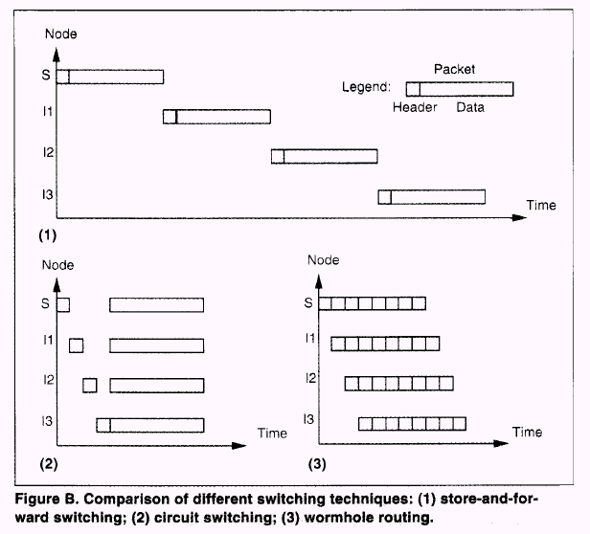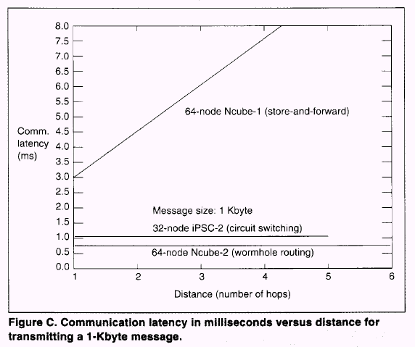
- Wormhole routing
Wormhole routing also uses a cut-through approach to switching. A packet id divided into a number of flits(flow control digits) for transmission.
Handshaking protocol
Wormhole routing allows a channel to be shared by many packets.
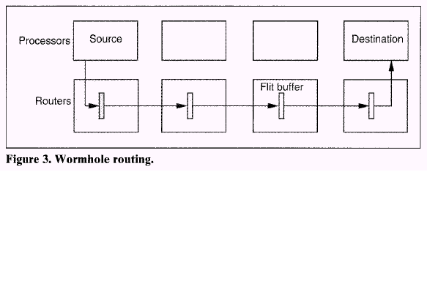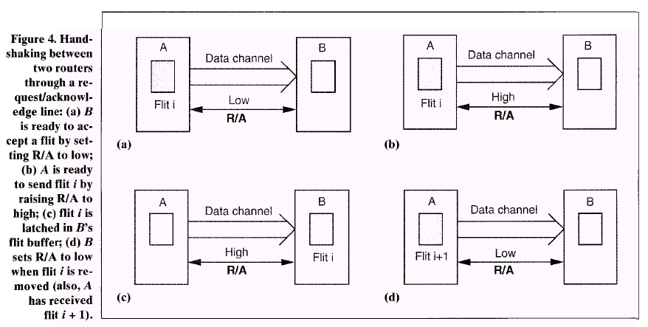
- Deadlock
A routing algorithm for a direct network is deadlock free if and only if there is no cycle in the channel dependence graph
Deterministic routing and Adaptive routing.
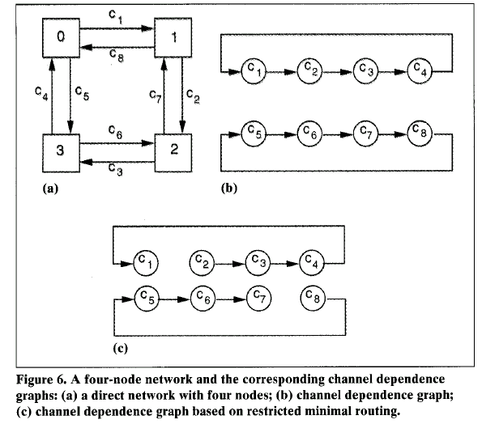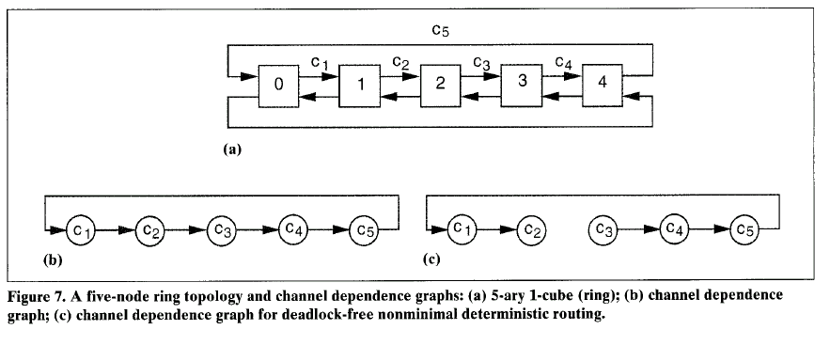
- Virtual channels 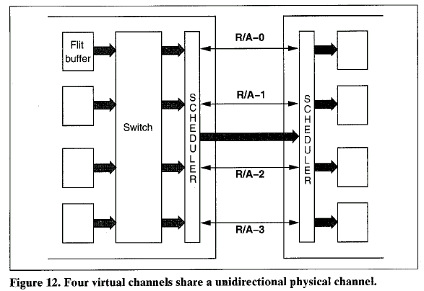
Created by : Ming-Cheng Lin
Date : Mar 3, 2000

